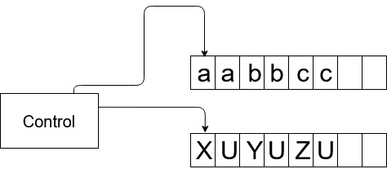

1. After receiving an input, create the output tape with number of "U" equal to m=3n. If the string is distributed inequally, take the highest n. (For example, in a^{n}b^{n}c^{2n} take n=2n so that m=6n. It is important for the checking if the string is in L .). In the case if n=0, go to the step 10.

2. If the w_{x} in the input tape is the first "a", set string as "X" in the same position of the both output and input tapes.

3. Move the input control right in the input tape till the first "b" in the input tape passing all "X"s and "a"s. Concurrently, move the output control to the same position at the output tape.

4. If the w_{x} in the input tape is "b", set string as "Y" in the same position of the both output and input tapes.

5. Move the input control right in the input tape till the first "c" in the input tape passing all "Y"s and "b"s. Concurrently, move the output control to the same position at the output tape.

7. If the w_{x} in the input tape is "c", set string as "Z" in the same position of the both output and input tapes.

8. Move the input control left in the input tape till the first "a". Concurrently, move the output control to the same position at the output tape.

9. Repeat steps 2-8 until there is no "a".

10. Move the output control in the output tape to the start.

11. Check the output tape for any "U".

12. If there are no "U" in the tape, jump to the step 13.

13. The string is accepted.

